DATE: 19.10.2018
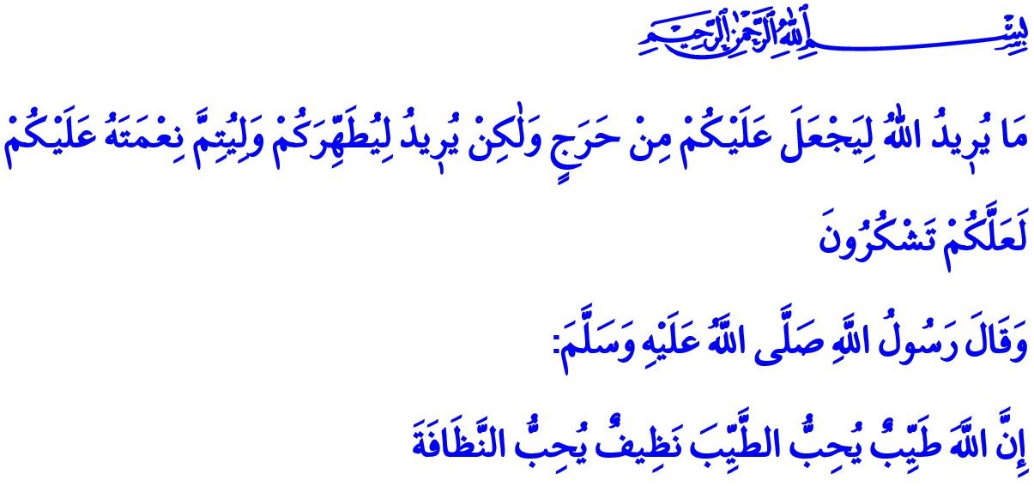 MATERIAL AND SPIRITUAL PURIFICATION: CLEANLINESS
Honorable Muslims!
After commanding wudu (minor ablution), ghusl (major ablution), and tayammum (dry ablution), Allah the Almighty (swt) states in the Holy Qur’an: “Allah does not intend to make difficulty for you, but He intends to purify you and complete His favor upon you that you may be grateful.”
In the hadith I have read, our Prophet Muhammad Mustafa (saw) says: “Allah is flawless from all kinds of imperfection, He loves his servants who are decent in their actions and words; He is clean, loves clean servants.”
Esteemed Believers!
Cleanliness is to be purified from the dirt and impurity both materially and spiritually, and to become pure and decent. It means keeping pure both our body, which is entrusted to us by our Lord (swt), and our heart, which attained peace with faith. Cleanliness is both the source of a healthy life and prerequisite of a precious act of worship as the prayer, which protects the believer from doing evil.
Dear Muslims!
Islam; is the religion of nature (fitrah) and life that encourages all kinds of material and spiritual cleaning. The universe is in a constant state of renewal and purification. All creatures on earth inherently try to be clean. Human being, however, has a special place and responsibility in terms of cleanliness among all other creatures as he is the most honorable of creatures. As a matter of fact, he is the one who both pollutes the nature and who will keep it clean.
Valuable Believers!
Cleanliness is in a sense purifying ourselves from the material dirt. The well-being of our bodies and the peace of our inner world is hidden in cleanliness. Body cleansing, oral and dental care constitute the primary stage of material cleaning befitting the honor of being human. Our beloved Prophet (saw) attached importance to this issue to the extent that he stated he would have ordered cleaning mouth by miswak if he had known it would not have been difficult for the Ummah.
Valuable Muslims!
When our Prophet (saw) received the revelation and was honored with the duty of prophethood after the seclusion period in the Cave of Hira, he was commanded: “And your clothing purify. And uncleanliness avoid.” It is not important whether the clothes are old, but it matters if they are dirty. Coming to the mosques with dirty clothes and socks, and disturbing our brothers and sisters with unpleasant smells is not a favorable attitude. Believers should be the exemplar of cleanliness, elegance and freshness wherever they are. When the Messenger of Allah (saw) met a man with dirty clothes, he said, “Could this man not find something to wash his garments with?”
In addition to cleaning the body and clothes, it is a religious and human duty to pay attention to the cleanliness of the environment and to keep clean the whole world that was made a place of worship for believers. It is our responsibility towards future generations to act according to the environmental ethics, for example by using recycle boxes for plastic and similar wastes instead of randomly disposing them.
Honorable Believers!
Cleanliness also refers to becoming purified of non-material uncleanliness. In this respect, it means for believers to protect their hearts, illuminated by Islam, from darkness and evil. It means recovering the heart from diseases such as arrogance, hypocrisy, envy, lie, stinginess, and embellishing it with beautiful traits such as humbleness, honesty, generosity, compassion, and decency. It means preventing the tongue, which is the mirror of the soul and the translator of the heart, from uttering vulgar and disgraceful words, impertinent talks, lies, and slanders. It means protecting their eyes, ears, hands, feet, and other limbs and organs from all kinds of evil and haram. It means always turning towards the halal in everything they are engaged in. It means loading off the burden of sins by repenting for them. Our Lord Almighty (swt) says in the Holy Qur’an, “Give glad tidings to those believers who repent, worship, praise Allah, travel for His cause, bow and prostrate in prayer for Him, and enjoin what is right and forbid what is wrong, and observe the limits set by Allah.”
Esteemed Believers!
Being clean and decent is the requirement of our faith. Let us pay due attention to the criteria of material and spiritual cleanliness as ordered by our religion. Let us neither leave our body uncared for and be ungroomed, nor go to extremes just to be well-groomed. As believers who hope for happiness in this world and in the Hereafter, let us be the exemplars of cleanliness and good morality. Let us give hope to others with our appearance; peace and reliance with our words and actions. Let our cleanliness be the evidence of our faith. Let us ensure that we keep our inside, outside, and surroundings clean.
Valuable Muslims!
The Presidency of Religious Affairs builds many mosques in Turkey and abroad with the support of our noble nation. We have full faith that our generous nation will contribute to the construction of mosques today, too, just as in the past. May our Lord Almighty (swt) allow us to continue worshiping with a clean body and pure heart, and not allow us to remain without the mosque and the adhan.

Ma’idah, 5/6.
Tirmidhi, Adab, 41.
Bukhari, Jumu’ah, 8.
Muddaththir, 74/4-5.
Abu Dawud, Libas, 14.
Tawbah, 9/112. General Directorate of Religious Services

